**(Michael Ng) Lab 1 – Maze Runner – Part I: Task List**

C:\Users\hallea1\IdeaProjects\GUIDemo\resources\robot.png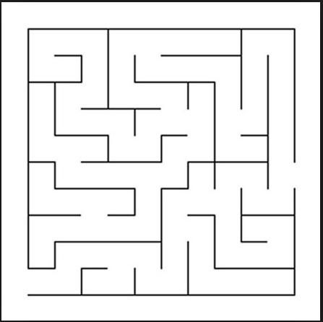

Mr. Zurcon’s lower body has been replaced with a hover engine. He no longer requires water. He does need to find his way through the maze above. Along with his engine upgrades, he will need a new instruction set. Remember, Mr. Zurcon can only understand very simple instructions.

1. Determine what steps are required to navigate the maze. Solve the maze yourself and pay close attention to your thought process as you make each decision.
2. Write each step out. Think about distance and direction.

Steps Needed

- Activate Engine/Thrusters

- Move Forward (Number of Blocks)

- Rotate Clockwise/Counter-Clockwise

- (Optional) Shut Down Engine/Thrusters

Instructions to Give

* Activate Engine/Thrusters
* Rotate 90o Clockwise
* Move forward 2 blocks
* Rotate 90o Counter-Clockwise
* Move forward 1 block
* Rotate 90o Clockwise
* Move forward 3 blocks
* Rotate 90o Clockwise
* Move forward 1 block
* Rotate 90o Counter-Clockwise
* Move forward 1 block
* Rotate 90o Counter-Clockwise
* Move forward 3 blocks
* Rotate 90o Clockwise
* Move forward 2 blocks
* Rotate 90o Counter-Clockwise
* Move forward 1 block
* Rotate 90o Clockwise
* Move forward 1 block
* Rotate 90o Clockwise
* Move forward 1 block
* Rotate 90o Counter-Clockwise
* Move forward 1 block
* Rotate 90o Counter-Clockwise
* Move forward 1 block
* Rotate 90o Clockwise
* Move forward 1 block